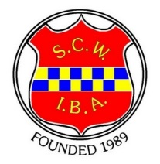
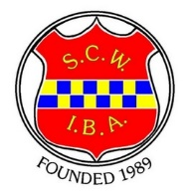
S.C.W.I.B.A. Competition Entry Form 2025-2026
Competitions to commence in November 2025
Clubs divided into two zones (see Website for Zones and Competition Rules)

*NOTE THE MAIN LADIES FINALS DATE Saturday 28th March 2026*
(Extra day if required the Sunday 29th March 2026).
The Ladies Championship will take place 2 pm Saturday 28th March 2026.
Please do not enter the Championship or other Competitions if you are not available for the date of the main Final.
(unless it’s a competition where a substitute may be used)

Contact Name....................................................................... Club........................................................................

Address....................................................................................................................................................................

Tel. No...................................................................e. mail……………………………………………………………………………………..
Competition |  | Tick for entry | Total
Championship Singles | £3
Ladies’ Prestwood Salver (Open to bowlers who have not won a county or national competition) | £3
Pairs: Lead

Skip | £6
Triples: Lead

Two

Skip | £9
Fours: Lead

Two

Three

Skip | £12
 | Grand Total
GDPR: I give my consent for my personal details to be listed on the SCWIBA website for Surrey Competition purposes.
Name: ………….……………………………………………… Signature: ………………………………………………

All Payments by BACS to 20-26-23 a/c 93579034 with ref Comps or Cheque made payable to SCWIBA by post to
Mrs Barbara Astill, Treasurer 17 Strathearn Ave, Whitton, Twickenham TW2 6 JT
Send completed entry form to: Competition Secretary Teresa Orriss: email teresa.orriss25@gmail.com
Text or WhatsApp 07904 585275
**PLEASE RETURN ENTRY FORM BY 31st OCTOBER 2025 **

